Personal Details: 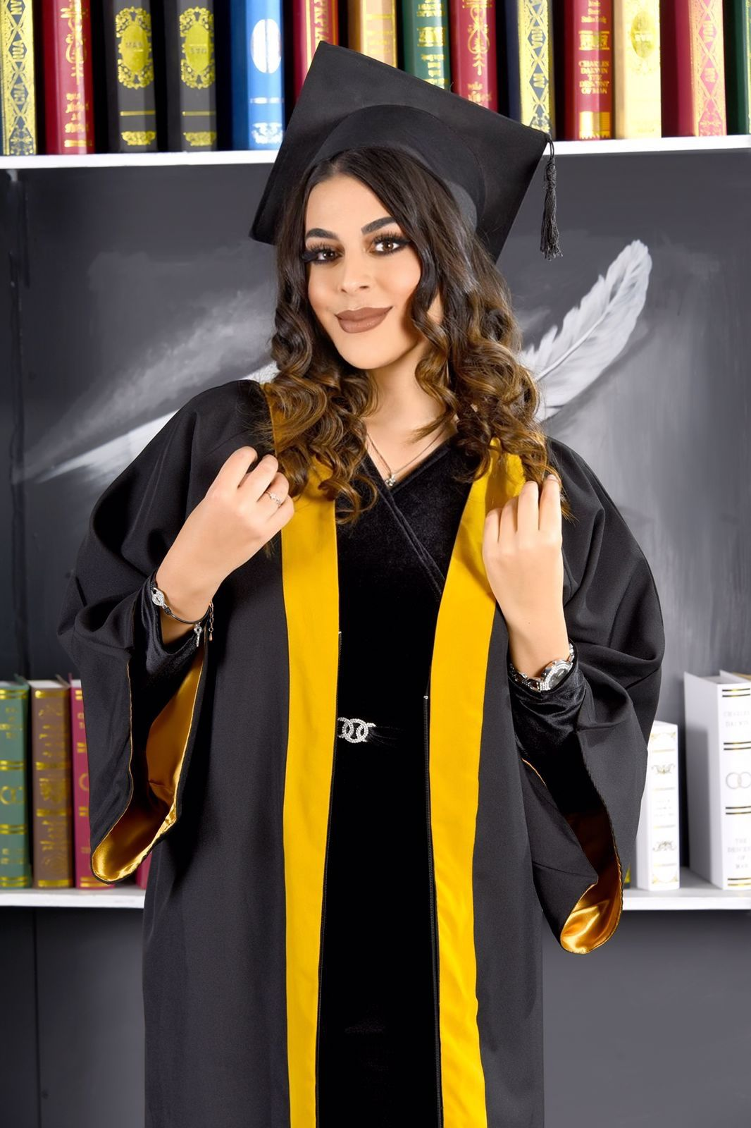
Curriculum Vitae

Name:Dania Moaiad Rayyan
Date of Birth: 10/11/2000
Address:Amman –Tla'Al-Ali
Nationality: Jordanian
Sex:female
Tele phone: 0795998427
E-mail:drayyan93@gmail.com

Education:
-Bachelor's degree of general Biology science / university of Jordan 2022/2023.
-certificate/ license to practice the profession in medical laboratory /university of Jordan 2022/2023

Courses and workshops:-
- research committee workshop.
-human development course workshop.
-how to think positive and how to achieve your goals workshop
-skincare course at el esraa hospital .
-nutrition course at Jordanian society for food and nutrition .
-preparation of materials microbiology course at university of Jordan.
Languages:-
*Arabic:- Mother tongue.
* English(very Good).
Work experience:-
1-promotion at many companies.
2-beauty advisor at pharmacy one.
3- giving organic chemistry lessons.
4- giving biology lessons and lectures for national and international systems.
5-science teacher in the international section in sands national school .
Skills:-
- Good knowledge of using desktop applications of computer.
- Good of communication with customers and gain their satisfaction.
- Working with team spirit.
- Excellent of interpersonal skills.
- Team Management.

Thank You.

str

